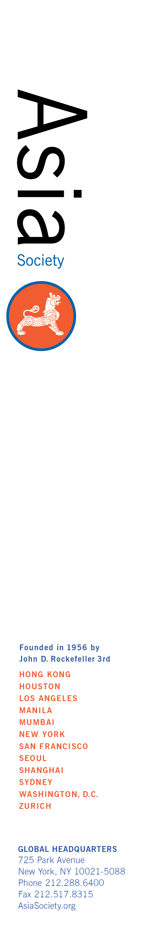**Asia Society Intern Opportunity**

**Location: Asia Society NY**

**Department: Events**

**Period of Internship: Fall 2018 / Winter 2019**

**Announcement: Asia Society Events Department Intern**

Asia Society’s Events Department is seeking a customer service focused individual interested in event planning and coordination. The Events intern will collaborate as part of a highly motivated energetic team in a fast paced entrepreneurial environment to plan, coordinate and execute various types of events from start to finish. The individual will interact with the Event Coordinator, the Event Administrator, colleagues, clients, vendors and support staff to successfully assist with event logistics along with key administrative and marketing functions. As an Events Intern you will be exposed to all facets of Asia Society’s Event operation, including communications, logistics, venue preparation and event setup, billing and invoicing, marketing and outreach. This internship allows an individual the opportunity to be both creative and analytical, while assisting with projects that are essential to the success of the Department. Availability on nights and some weekends is essential.

Candidates are asked to commit to a minimum of 12 weeks.

Schedule is flexible.

**Education /prior experience most suited for this internship:**

Customer service focus; ability to function independently and as part of a dedicated team; ability to assist in the setup and preparation of the events at Asia Society; proficient computer skills including Microsoft Office, Google Platforms and Photoshop; skilled with social media platforms; effective research, writing and communications skills; strong organizational skills; detail oriented; ability to multi task, perform well under pressure and adhere to deadlines in a fast paced, entrepreneurial environment;

Internship is nonpaid, but academic credit can be offered.

**How to Apply:**

**Please email or mail your letter and resume indicating intern title to:**

**Name: Anne Godshall**

**Asia Society**

**725 Park Avenue**

**New York, NY 10021-5088**

Email: [AGodshall@asiasociety.org](mailto:AGodshall@asiasociety.org)

No phone calls, please. Only those candidates considered for an interview will be contacted. If you submit your resume by email, please regard it as having been received unless your email has bounced-back.