Course: Career and Customer Service is a course that focuses on the strategies and skills related to career success and customer satisfaction in the hospitality and tourism industry.
Assignment: Careers in the Hospitality Industry (created for an asynchronous online course)
Assignment Learning Outcomes
- Identify career opportunities in the hospitality industry locally and globally
- Create a career path to fit your interests and needs
Assignment Learning Plan
- Students will review the career planning process: 1) self-assessments, 2) explore the occupations, 3) create a career path including short-term and long-term goals, and 4) take action for your career path.
- Students will complete readings from their professionalism textbook and complete a career assessment.
- Students will be introduced to career resources to explore potential occupations or learn about occupations they are interested in pursuing. Examples of resources available:
The Occupational Information Network (O*NET) (US Department of Labor/Employment and Training Administration)
Hawaii Industry Data Occupational data within individual sectors and across all sectors for a holistic snapshot of industry demands and trends
Careers in Hawaii Hotels and Resorts
Exploring Careers Beyond Hotel and Resorts within the Hospitality Industry
Global Hospitality Careers Leading hospitality recruitment and executive search firm specializing in identifying, evaluating, and placing senior-level leadership and management talent, locally and internationally.
Hospitality industry companies include hotels, resorts, restaurants, spas, private clubs, casinos, private clients, theme parks and food service companies for properties in North and South America, Europe, the Middle East, the Far East, Australia, and, of course, Canada, and the USA
- To emphasize global competence, students will need to:
1) View the What is Global Competence video from Asia Societies Center for Global Education Student module #1 http://asiasociety.org//video/defining-global-competence?utm_source=asiasociety.org&utm_medium=jwplayer&utm_campaign=video while referring to the Global Competencies handout.
2) View the World of Hospitality Video from the Asia Societies Center for Global Education Student module #3 https://asiasociety.org/video/world-hospitality which is Kimo Kippen’s, chief learning officer at Hilton Worldwide, views about the wide range of careers available in the world of hospitality.
Assessments
- Part 1-Written Reflection: After reviewing the Global Competence video and the World of Hospitality video, students will reflect on the following questions from the Global CTE Toolkit:
What skills does the speaker believe are important for working with diverse cultures?
What skills does the speaker believe are important for entering this career field?
Based on what the speaker says, what skills do you currently have?
Based on what the speaker says, what is one thing you can do to prepare yourself for this career field?
Based on what the speaker says, what are some next steps you could take to be more marketable in this career field globally?

- Part 2-Research Careers: Students will use the informational tools on the career assessment and career resources to explore/research three potential hospitality related occupations/career choice. While researching, these are the items they will want to learn more about:
  - Specific work activities
  - Common work activities
  - Interests
  - Skills & Abilities including Global Competencies
  - Working Conditions
  - Physical Demands
  - Hiring Practices
  - Current Employment
  - Wages
  - Knowledge
  - Licensing/Certification/Designation/Registration
  - Preparation
  - Outlook
  - Advancement Opportunities

- Part 3-Occupational Research Summary: Students will complete the Careers in Hospitality assignment after they select and research three occupations. They will be encouraged to visit/cite companies’ career and job posting information from corporate websites by sharing the links to the websites they obtained their information from.

Global Competencies

The idea of global competence articulates the knowledge and skills students need in the 21st century.
Globally competent students have the knowledge and skills to:

Investigate the World
Globally competent students are aware, curious, and interested in learning about the world and how it works.

Recognize Perspectives
Globally competent students recognize that they have a particular perspective, and that others may or may not share it.

Communicate Ideas
Globally competent students can effectively communicate, verbally and non-verbally, with diverse audiences.

Take Action
Globally competent students have the skills and knowledge to not just learn about the world, but also to make a difference in the world.
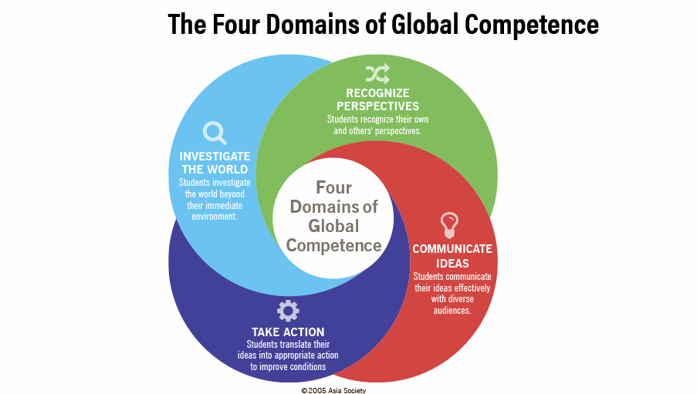

Careers in Hospitality & Tourism
Conduct internet research to identify various careers in the hospitality and tourism industry locally or internationally. Many companies have career and job posting information on their corporate sites. Select three that you might be interested in and provide the information below. Include the links to the websites you accessed to obtain the information. You will be using your research to complete subsequent career related assignments such as your academic pathway assignment.
Company Name | Job Title | Brief Job Description | Minimum and Desired Qualifications | Your Action Plan to Meet the Qualifications
1.
2.

3.

