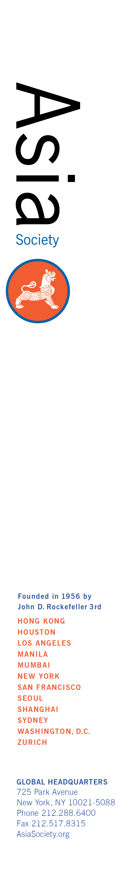**Asia Society Intern Opportunity**

**Location:** Asia Society, 500 Washington Street, San Francisco

**Department:** All as needed

**Period of Internship:** Fall**,** 2018

**Announcement:**

The Asia Society’s Northern California Center is seeking an internwith an interest in Asian and Asian American issues to assist with development ideas, social media, and outreach activities to promote programs.

Program activities include public events, private workshops, and report launches. This is an exciting opportunity for selected interns to learn more about specific issues as related to Asia or Asian Americans while cultivating their digital marketing, program research, and social media-based skills.

The staff from each department will instruct the interns as how to assist with communications and marketing activities for specific public events including layout and design of marketing materials; creation of the weekly newsletter and event announcements; develop original content for the Asia Society website and blog; research and implement outreach; create, edit and produce multimedia content, such as video and photo slideshows; assist with event coordination and logistical duties; plus research topics for social media and assist with a social media strategy through outlets like Facebook and Twitter.

We are currently recruiting interns **now and for Fall, 2018.** Internships are **unpaid** positions. Candidates are expected to intern between the second week of August and the second week of December for 16 hours a week; availability twice a month for events may be requested. For applicants not able to meet these conditions, we may have program-specific volunteer opportunities.

**Education /prior experience most suited for this internship:**

College juniors/seniors, recent graduates, and graduate students in Asian and Asian American studies, business, international affairs, journalism, history, political science or related fields preferred; strong interest in programming and Asian affairs; knowledge of or experience in working on a range of social, cultural, economic, and political issues related to Asia, U.S.-Asia relations, and Asian Americans; strong research, writing, and editing skills; skill and experience using social media as a marketing tool, with previous marketing and journalism experience a plus; proficiency using video equipment, editing software (e.g. FinalCut, Adobe Premium Pro), and Adobe Creative Suite a strong plus; excellent attention to detail; reliable self-starter and problem-solver who is able to meet tight deadlines; and flexibility and ability to multi-task in fast-paced, entrepreneurial environment.

**How To Apply:**

E-mail, in a ***single PDF or Word file***, with the subject line "ASNC Internship Fall 2018” to sanfrancisco@asiasociety.org:   
  
**1)** a cover letter, indicating your interest and qualifications for the internship and the days and hours you are available;  
**2)** a resume, and   
**3)** a short writing sample (3-5 pg. max).  
   
**Incomplete applications will not be considered**. Due to the large volume of applications we receive, we are only able to contact those candidates selected for interviews. No phone calls, please.

