Sep 16 2015
Hong Kong China

Asia Society Hong Kong Center Brings Bats To The Gallery: Exploring the symbol of the bat in Chinese art
by Simon Frank
September 16 saw the opening of “Bat Cave,” at the Asia Society Hong Kong’s Chantal Miller Gallery. Inspired by the presence of fruit bats around Asia Society’s Hong Kong ​C​enter, the exhibit (open until January 3, 2016) examines the role of bats as a symbol of blessings and prosperity in traditional Chinese culture. “Bat Cave” presents artifacts from the Qing dynasty(1644–1912) along with work by Chinese contemporary ink artist Sun Xun. Sun created the site-specific mural The “Dao” of a Bat (2015) in the days leading up to the exhibition opening. In vivid splashes of black ink and gold paint, the artist covered one of the gallery’s walls in bats and abstracted landscapes. Sun explained that the use of gold in addition to Chinese ink was inspired by Japanese traditional painting, connecting the new mural to his 2010 animation Beyond-ism, also on display. The video retold the myth of sorcerer Xu Fu, who under China’s first emperor was purportedly sent to find the land of immortality, thought to be Japan. Anachronistically depicting modern buildings along with bats, Sun drew traditional arts into the present.
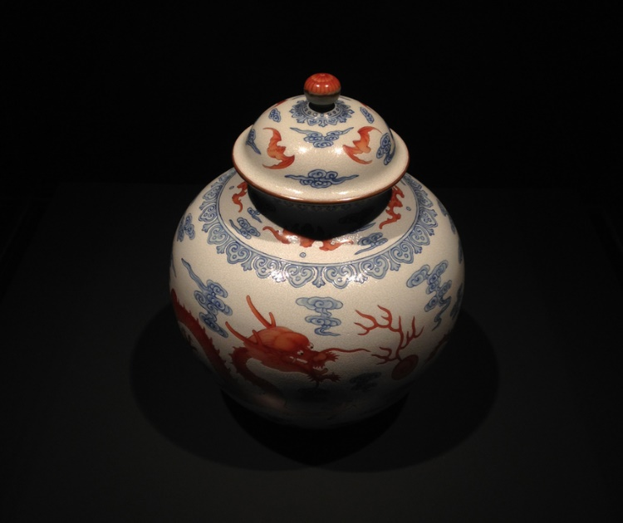
Jar with iron-red dragon-and-flaming-pearl design on white background, from the period of Qianlong (1736-1795), Qing Dynasty​. All photos by Simon Frank for ArtAsiaP​acific.

