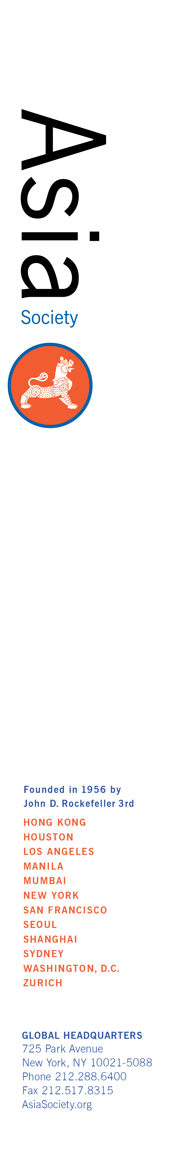**Asia Society Intern Opportunity**

**Location:** New York

**Department:** Asia Society Policy Institute

**Period of Internship:** Spring / Summer, Fall 2017

**Announcement:**

The Asia Society Policy Institute (ASPI) is seeking an exceptional intern with a demonstrated interest in the social, political, and economic challenges in Asia. This intern should have strong research/writing skills and interest in at least one of the following areas:

1. Prosperity: Strategic and economic architecture for the Asia Pacific that is inclusive and enhances long-term stability, trade, and economic connectivity.
2. Security: The rise of emerging powers in Asia, the strategic ramifications of their growing economic, political, and military power, and their relations with the United States.
3. Sustainability: Climate change, environment, and sustainable development issues across Asia.

The intern will learn how to track and research current developments in Asia; write, edit, and proofread policy memos and event/meeting summaries. They will also provide conference/event coordinating support and will have the opportunity to attend and report on meetings at the United Nations and at various NGOs in New York City.

Internships are **unpaid** positions. Candidates should be able commit to a minimum of 10 weeks, and at least three days per week, or the equivalent of 24 hours per week. For the summer term, full time availability is preferred. Evening availability once or twice a month for events may be requested.

**Education /prior experience most suited for this internship:**

Previous internship experience preferred; strong familiarity with global issues and/or Asia; strong research, writing, and editing skills; excellent attention to detail; reliable and able to excel under tight deadlines; proficiency with Microsoft Office; flexibility handling diverse tasks; native or full professional proficiency in English

**How to Apply:**

E-mailthe following documentsin Word or PDF format with the subject line *“ASPI Internship NY – Spring/Summer/Fall (specify which one) 2017" t*o [PolicyInstitute@asiasociety.org.](mailto:PolicyInstitute@asiasociety.org.):

1. A cover letter, indicating your interest in the position and the days and hours you are available to be at Asia Society;
2. A resume; and
3. A writing sample (3–5 double-spaced pages; abstracts are accepted)

**Application Deadlines:**

|  |  |  |
| --- | --- | --- |
| **Term** | **Internship Duration** | **Applications Must be Received by our Office No Later than 11:59PM EST** |
| **SPRING** | January - May | November 15, 2016 |
| **SUMMER** | June – August | March 30, 2017 |
| **FALL** | September – December | July 15, 2017 |

We will not consider incomplete applications. Due to the large volume of applications we receive, we are only able to contact those candidates selected for an interview. No phone calls, please. Please consider your application received unless your email bounces back.