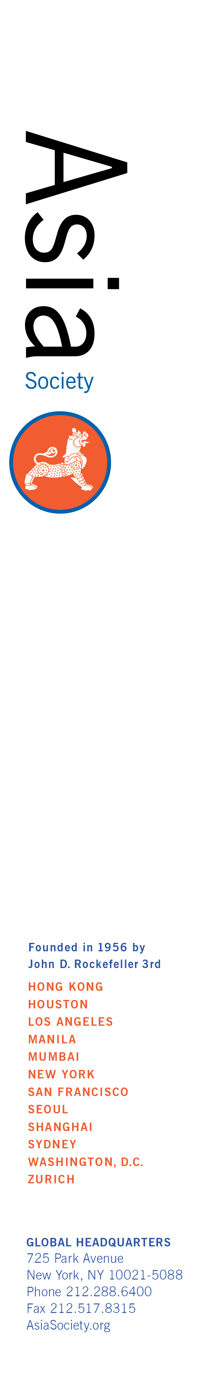**Asia Society Intern Opportunity**

**Location:** Asia Society, 500 Washington Street, San Francisco

**Department:** Programs

**Period of Internship:** Spring-Summer**,** 2017

**Announcement:**

The Asia Society’s Northern California center is seeking interns with an interest in Asian and Asian American issues and culture to learn the machinations of program activities, including public events, private workshops, and reports. This is an exciting opportunity for selected interns to gain hands-on experience in program conceptualization, development, and execution and work on multimedia projects while learning about social, political, and cultural issues in contemporary Asia.

The Programs team staff will instruct the interns in all aspects of program development, from researching program topics and speakers to providing logistical support at public events; track and research specific topics in the U.S. and Asia that relate to programming (e.g., in policy, foreign relations, finance and business, Asian American issues, sustainability, or arts & culture); assist with communications and marketing activities, including layout/design of marketing materials (e.g. quarterly newsletter, event announcements), and develop original content for the Asia Society website, blog, and social media sites.

We are currently recruiting interns for **Spring**-**Summer, 2017.** Internships are **unpaid** positions. Candidates are asked to commit to a minimum of 12 weeks and at least 16 hours a week; availability twice a month for events may be requested. For applicants not able to meet these conditions, we may have program-specific volunteer opportunities.

**Education /prior experience most suited for this internship:**

College juniors/seniors, recent graduates, and graduate students in Asian and Asian American studies, business, international affairs, journalism, history, political science or related fields preferred; strong interest in programming and Asian affairs; knowledge of or experience in working on a range of social, cultural, economic, and political issues related to Asia, U.S.-Asia relations, and Asian Americans; strong research, writing, and editing skills; skill and experience using social media as a marketing tool, with previous marketing and journalism experience a plus; proficiency using video equipment, editing software (e.g. FinalCut, Adobe Premium Pro), and Adobe Creative Suite a strong plus; excellent attention to detail; reliable self-starter and problem-solver who is able to meet tight deadlines; and flexibility and ability to multi-task in fast-paced, entrepreneurial environment.

**How To Apply:**

E-mail, in a ***single PDF or Word file***, with the subject line "ASNC Programs Internship Spring-Summer 2017”:   
  
**1)** a cover letter, indicating your interest and qualifications for the internship and the days and hours you are available;  
**2)** a resume, and   
**3)** a short writing sample (3-5 pg. max) to [mlabouff@asiasociety.org](mailto:mlabouff@asiasociety.org).  
   
**Incomplete applications will not be considered**. Due to the large volume of applications we receive, we are only able to contact those candidates selected for interviews. No phone calls, please.

